**SUPPLEMENTARY MATERIALS: Faster, Cheaper, Better: High frequency soil respiration measurements using an NDIR CO2 sensor and Low-cost Arduino-based Monitoring Platform (CO2-LAMP)**

**Necessary Components**

* Arduino Uno R3 Data Logger
  + <https://store-usa.arduino.cc/products/arduino-uno-rev3>
* Adafruit Data Logging Shield
  + <https://www.adafruit.com/product/1141>
* Power source
  + 9v Arduino compatible AC power adapter
    - <https://www.amazon.com/dp/B018OLREG4?ref=ppx_yo2ov_dt_b_fed_asin_title>
  + OR 9V Arduino compatible battery pack
    - <https://www.adafruit.com/product/67?gad_source=1&gbraid=0AAAAADx9JvQL43jnsR-FVzaVfERvsAPav&gclid=Cj0KCQiA0fu5BhDQARIsAMXUBOJj4brJFIg6JKCPyW5OE4ls7IH6MYatHPB_IVxFAKZRLW2SaCSUFbIaAlh_EALw_wcB>
* Pololu 12V Step Up Step Down Voltage Regulator
  + <https://www.amazon.com/dp/B01M9CDXVZ?ref=ppx_yo2ov_dt_b_fed_asin_title>
* Grove 2-Coil Latching Relay
  + <https://www.electromaker.io/shop/product/grove-2-coil-latching-relay?gad_source=1&gbraid=0AAAAAB8F3FmVLintFGt7a4qYzgW1fJBna&gclid=Cj0KCQiA0fu5BhDQARIsAMXUBOKB3JzYas3g0yNWNvnCIDMDPMvEmG57cfKfz6l9h6ScReNfHHWximYaAuHZEALw_wcB>
* K30 CO2 sensor (10%)
  + <https://www.co2meter.com/products/k-30-co2-sensor?variant=79646062>
* Marine Epoxy Putty
  + <https://www.amazon.com/PC-Products-25567-PC-Marine-Moldable/dp/B000H5ORDO/ref=sr_1_3?crid=380MRWV9G41TS&dib=eyJ2IjoiMSJ9.48RWuCT5LW6i9pKYFmP9oXZS8L1pKV4K5CmlUDCXOWE688h5-i0v7JhkClCW5qiq7J968ObZhBd9fh1H6nEiK6V1tqbNvK4lWt5QW2UdDrbS0oVo-7T-mxIei7yKIZLJvN5_JuJ4lpyRYVXv7RidSFdQqDoD5S26h5ivYPqCzmv37eEgdX7yx6TA45uwmKYJd6S0od_ao_0rr6u6Tixv2fGM3Y62qCeBRQjux3jqXxU.LtDso2DXzkSVTVH-zoMCD3vnosns3IGc_XpYLrPxYj4&dib_tag=se&keywords=marine+Epoxy+putty&qid=1732225220&sprefix=marine+epoxy+putty%2Caps%2C179&sr=8-3>
* Quick Set Liquid Epoxy
  + <https://www.amazon.com/J-B-Weld-50172-MarineWeld-Adhesive/dp/B00R2CDVIW/ref=sr_1_5?crid=TAUKKOJDXL4T&dib=eyJ2IjoiMSJ9.hbrDLHHZNOQHo9y8HSO-zNajGjEYP3qKytW4flqXJMe-DJnWbNsSrFBMvUvxtS0zokj_mASZl5Y4R1zOvZU7O_ebC5YMged6u_mf8up977RNrrF3H23MMfO4_UGfLbzpRoUryRF247XUXQRa9sty99-uCFghd3x_zEKT6sFWPa7UB2gtrFjUGizCGhL8uRIk9s9R16NIh8ZHI5LiZmHlDBFGCRkwJwHGmvnvXSgoygt5Bse_qtxz5CnofTxnVIq1CJ26ffqVDVEc_wqJdrqtYYdu598oYZF66uBwy_eoVDE.7AMcxZBaxkwawpVzwPR-LXVqBSHcw4os0OOJISE7Ltk&dib_tag=se&keywords=marine%2BEpoxy&qid=1732225303&sprefix=marine%2Bepoxy%2Caps%2C216&sr=8-5&th=1>
* Mason Jar
* Plastic Mason Jar Lid
* Gas Port with septa
* SD Cards

**Equipment/Tools**

* Dremel Tool
* Soldering iron
* Fume Hood or well-ventilated space
* Data Cable(s)
* Computer
* Heat Gun and Heat Shrink Tubing OR Electrical tape
* Solder wire
* Coated 22 gauge wire
  + Ideally you want black, red, green, and yellow
    - <https://www.amazon.com/dp/B00XW2O95A?ref=ppx_yo2ov_dt_b_fed_asin_title>

**Construction Process**

1. Make a template
   1. Take a picture of the sensor, and print it out, use the zoom function on your printer as needed to get the size correct. Cut out your template, and draw the outline of the sensor on the mason jar lid

1. Cut hole in lid of mason jar
   1. Use a Dremel cutting bit
   2. Scratch up the surface of the lid around the edges of the hole to make it easier for the marine epoxy to bond
   3. Cut a hole for your gas port as well

1. Check sensor fit
   1. Make sure the sensor fits into the hole that you’ve cut, and ensure that it sits flush with the lid

1. Connect Data Shield to Data Logger
   1. Break off the correct number of pins from the pin sets included with your data shield and insert them into the black female sockets on the data logger

* 1. Set the Data shield onto the pins. The pins should poke up through the matching holes on the data shield

* 1. Solder the pins to the data shield

1. Prepare Power source
   1. Cut the end off of the power source, leaving 2-3 inches of wire on the end and strip ~1/2 inch of the red and black + and – wires on either side of your cut.A black power adapter with wires

      Description automatically generated
   2. Cut 2 lengths of red wire and two lengths of black wire, and strip ~1/2 inch of wire from either end of each wire. Then twist one end of each wire together with the black and red wire at the port end of the power source. If you choose you can further bond these joined sections with solder. Wrap with electrical tape or heat wrap.

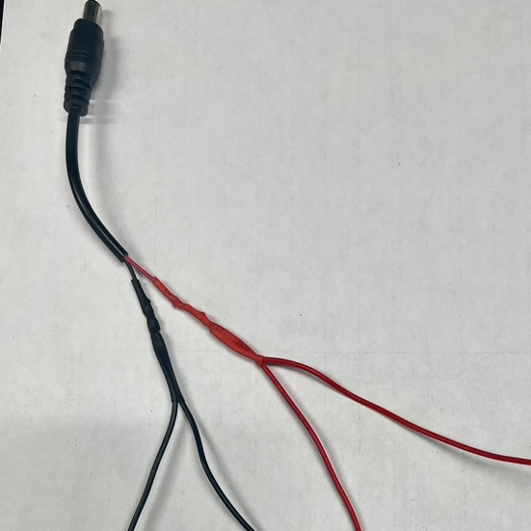

1. Connect Power source to voltage regulator
   1. Insert the + and – wires from the wall side of the power source into the voltage regulator

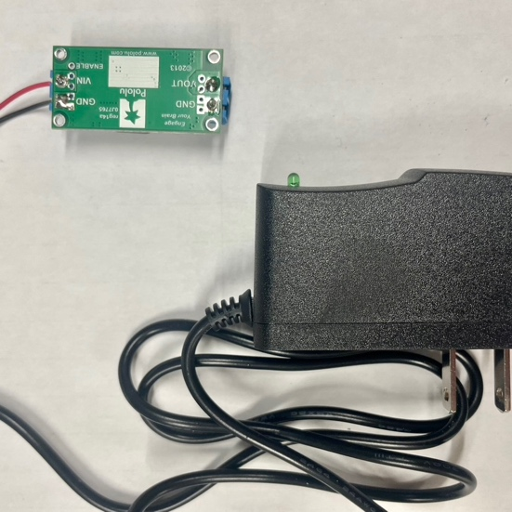

1. Prepare the 2 Coil Latching Relay
   1. Plug one end of the included cable into the white port on the relay. Cut the white port off of the other end, and strip ~1/2 inch sections of the red, black and yellow wire. Fold the white wire back, and use electrical tape or heat seal to keep it out of your way.

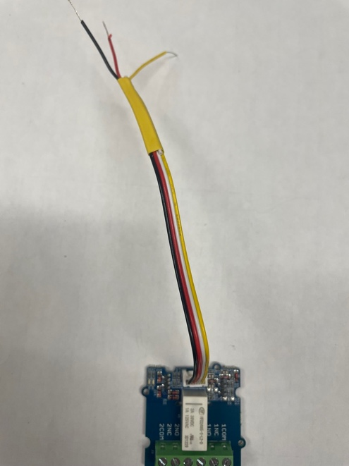

1. Create a cable for the CO2 Senser
   1. Cut 4 lengths of 22 gauge wire in Black, Red, Green and Yellow. This will make the cable that runs between your mesocosm and your data logger, so it should be long enough to easily move around, but not so long as to take up un-necessary space or affect data transit. Around 1.5 to two feet is usually sufficient. You can use heat seal or electrical tape to connect these four wires every few inches to keep them tidy. Strip ~1/2 inch sections of each wire on either end.   
      A close up of a wire

      Description automatically generated
2. Wire the Sensor
   1. Solder the black, red, green, and yellow wires to the CO2 sensor as shown:

1. Connect Sensor, Relay, Power Source

1. Test the sensor
   1. Plug in the data logger and insert an SD card into the SD port
   2. Connect your sensor to your computer
   3. Download the Arduino IDE from Arduino.cc
   4. Create a new sketch
   5. Copy the program from github and paste it into your sketch. Make sure you have all of the correct libraries installed
      1. <https://github.com/CovingtonResearchGroup/CO2-LAMP>
      2. This program is set to take readings at 10 minute intervals. You can adjust this setting by changing the READ_INTERVAL
         1. 1 minute = 60000; 1 second = 1000
         2. Be sure that the LOG_INTERVAL is set to the same time or less than your READ_INTERVAL to ensure that every reading is logged onto the SD Card.
   6. Select your Arduino from the dropdown menu at the top of the IDE window
   7. Click the check mark to verify the sketch
   8. Click the right arrow to upload the sketch
   9. Open a serial plotter window with the graph button at the top right
   10. Breath onto the sensor to change the CO2 concentration
   11. You should see the reading change on the serial plotter or on the serial monitor
       1. If you reset the reading interval to 10 seconds, this is easier to see
   12. The sensor will have an orange flashing light visible through the white fabric that covers the sensor, and through the viewport on the other side of the control board; the data logger will make a clicking noise when it takes a reading.
   13. If your sensor is working correctly, continue to the next step. If not, check your solders and connections.
2. Attach sensor to lid with marine epoxy putty
   1. Pinch of a section of putty and mash it together with your fingers. Once it is uniform in color, roll out a coil of the epoxy and use it to surround the holes in the mason jar lid

* 1. Insert the sensor and the gas port into the lid, pressing firmly to ensure that the putty adheres

* 1. Turn the lid over and seal the edges of the control board and plug all gaps in sensor control board with marine epoxy

* 1. Cover sensor with quick set liquid epoxy to complete the seal

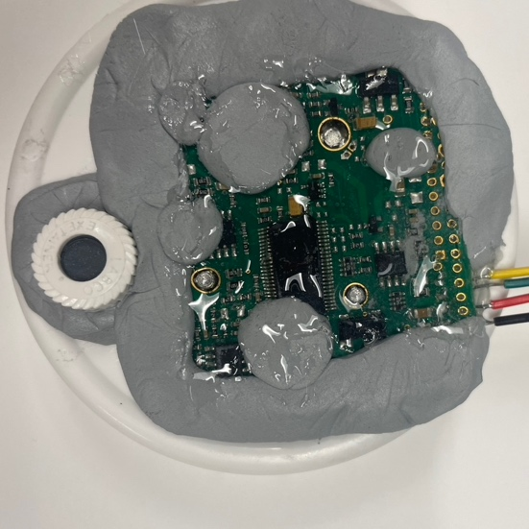

**Testing for leaks**

* + Put the lid with the sensor on the mason jar and twist to seal (it’s easier to turn the mason jar than the lid)
  + Using a calibration gas of known concentration, fill the jar with calibration gas (use a “pigtail” to let gas out of the mesocosm so that pressure doesn’t build up)
    - To use as little gas as possible, connect the CO2-LAMP to your computer and use the serial monitor to determine when the gas concentration in the jar matches your calibration gas.
  + Leave the jar overnight with the sensor powered on and reading.
  + Check in the morning to see how quickly the concentration in the jar drops.
    - Electrical putty applied to seams and over the septa of the gas port help to minimize leaks.
    - Silicone caulk applied to the inside of the lid around the edge can also minimize leaks, but should be applied carefully or it may exacerbate leaks.

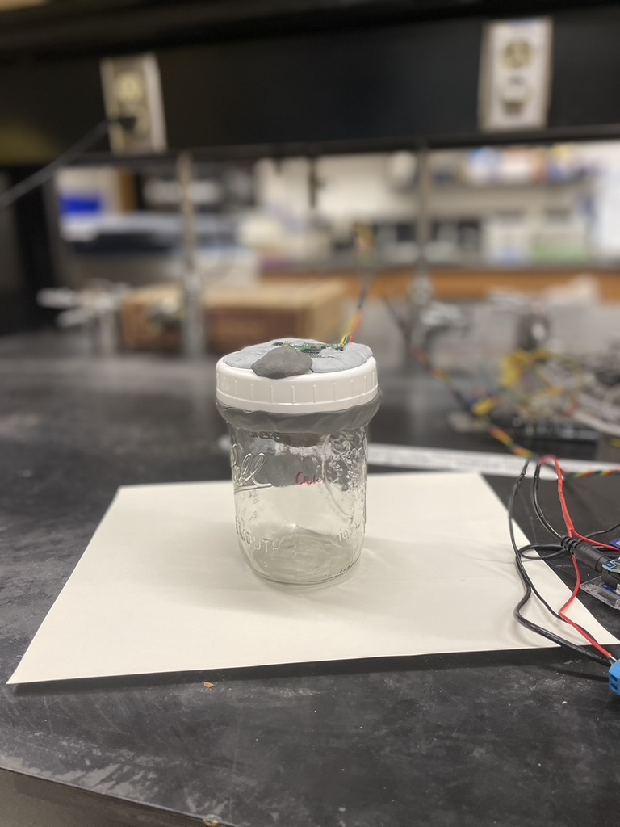

**Sensor Calibration**

* You will need at least calibration gasses of known concentration
  + 500ppm, 5000ppm and 50000ppm (0.05, 0.5, 5%) is a good set of standards to use
* Put the lid with the sensor on the mason jar and twist to seal (it’s easier to turn the mason jar than the lid)
* Fill the jar with calibration gas (use a “pigtail” to let gas out of the mesocosm so that pressure doesn’t build up)
  + To use as little gas as possible, connect the CO2-LAMP to your computer and use the serial monitor to determine when the gas concentration in the jar matches your calibration gas.
* Repeat the process with the other two calibration gasses
* Use the measured values from the sensor and the known values of the gases and make a plot of measured values vs calibration values. If you do this in excel you can have excel develop the calibration formula for you based on your data